DSDV(Destination Sequenced Distance Vector) [Table Driven & Proactive]
- The DSDV routing protocol is an enhanced version of the distributed Bellman-Ford algorithm where each node maintain a table that contain the shortest distance and the first node on the shortest path to every other node in the network.
- Each entry in the routing table contains a sequence number, the sequence numbers are generally even if a link is present; else, an odd number is used. The number is generated by the destination, and the emitter needs to send out the next update with this number. Routing information is distributed between nodes by sending full dumps infrequently and smaller incremental updates more frequently.
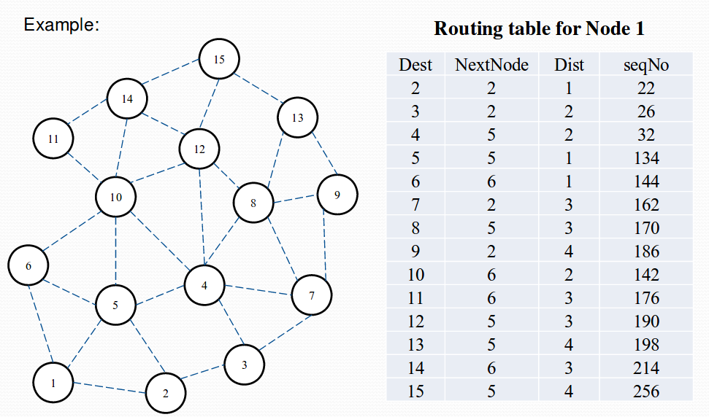
- Each node, upon receiving an update, quickly disseminates it to its neighbors in order to propagate the broken-link information to the whole network. Thus a single link break leads to the propagation of table update information to the whole network.
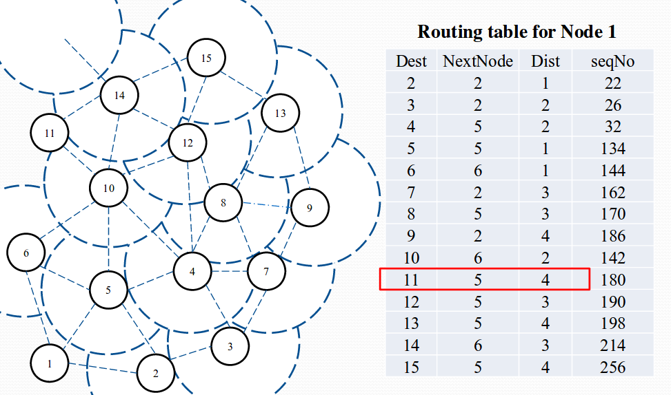
AODV(Ah-hoc On-demand Distance-Vector) [On-demand Driven & Reactive]
- In AODV, a route is established only when it is required by a source node for transmitting data packets. The source node and intermediate nodes store the next-hop information corresponding to each flow for data packet transmission.
- AODV utilizes routing tables to store routing information. The table stores:
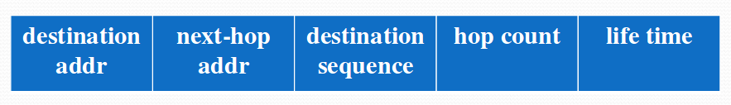
- If a node wants to send a packet to some destination. At first, it checks its routing table to determine whether it has a current route to the destination or not.
If yes, it forwards the packet to next hop node of the route.
If no, it initiates a route discovery process.
The Route discovery process begins with the creation of a RouteRequest (RREQ) packet. Broadcasting is done via flooding.
- Sender S broadcasts a RREQ to all its neighbors, each node receiving RREQ forwards RREQ to its neighbors.
- An intermediate node (not the destination) may also send a RouteReply (RREP) packet provided that it knows a more recent path than the one previously known to sender S.
- As an intermediate node receives the RREP packet, it sets up a forward path entry to the destination in its routing table.
- The source node can begin data transmission upon receiving the first RREP.
Example:
  - Node S needs a routing path to node D.
  - Node S creates a RREQ packet
RREQ [D’s IP addr, seq#, S’s IP addr, seq#, hopcount]
  - Node S broadcasts RREQ to its neighbors.
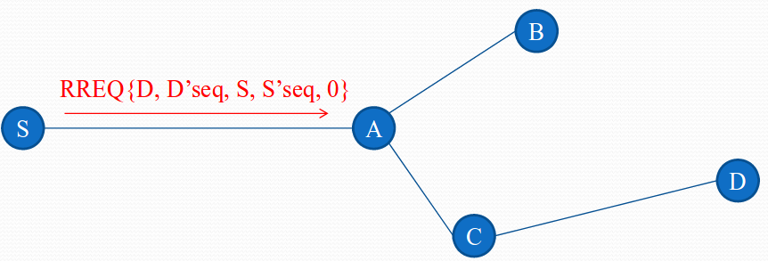

  - Node A rebroadcasts RREQ to all its neighbors.
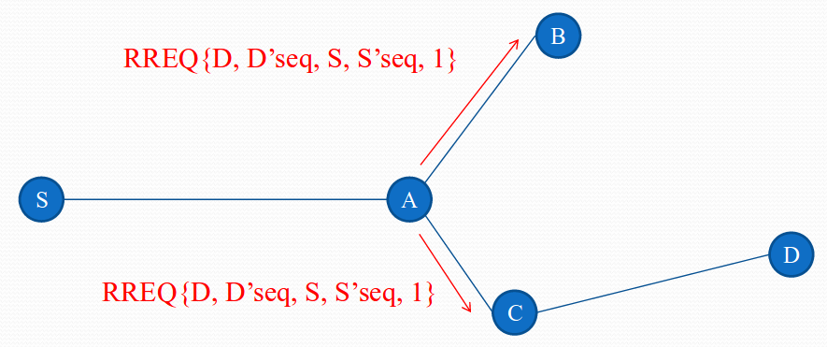

  - Since, node C known a route to D.
Node C creates a RREP packet and unicasts RREP to A.
Set forward path in node C’s routing table.
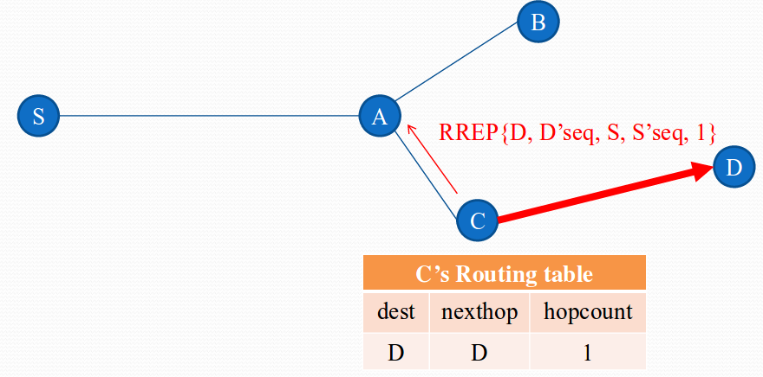

  - Node A creates a RREP packet and unicasts RREP to S.
  - Set forward path in node A’s routing table.
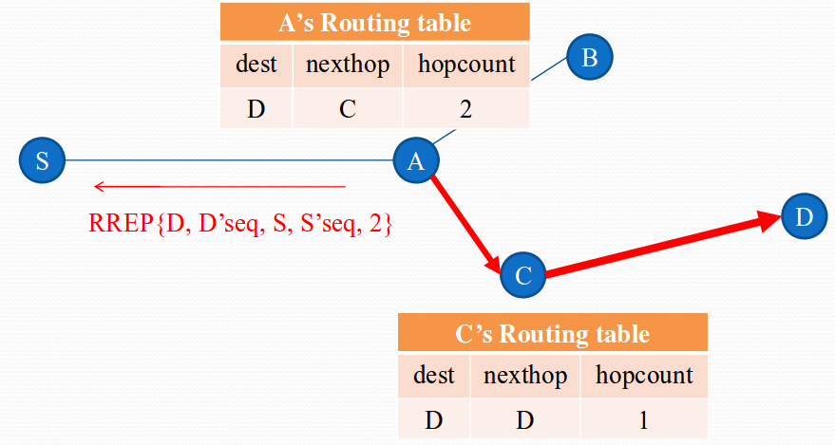

  - Set forward path in node S’s routing table.
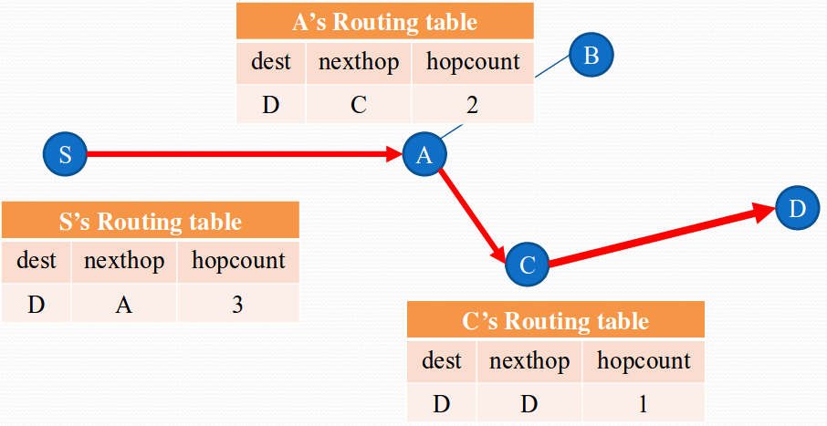

  - Assume link between C and D breaks.Node C invalidates route to D in route table.
Node C creates RRER(RouteError) packet and sends to its upstream neighbors.Node A sends RRER to S.Node S rediscovers route if still needed.
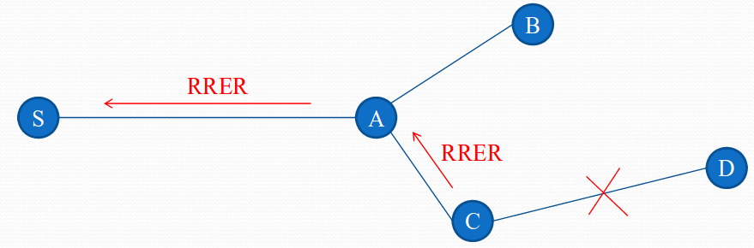

DSR(Dynamic Source Routing) [On-demand Driven & Reactive]
- It is similar to AODV in that it forms a route on-demand when a transmitting node requests one. However, it uses source routing instead of relying on the routing table at each intermediate device.
Example:
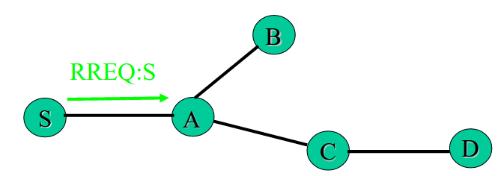

1. Node S needs a route to D
2. Broadcasts RREQ packet
3. Node A receives packet, has no route to D
❒ Rebroadcasts packet after adding its address to source route
❒ Upon receiving a RREQ, the node takes the following actions:
1. The node is the Target (Destination)
❍ Returns a Route Reply (RREP) message to the sender
❍ Copies the accumulated route record from RREQ into RREP
❍ Sender upon receiving RREP, caches the route in its route cache for subsequent routing
2. The node is the intermediate node
❍ The node discards this message, if The message has the same ID i.e. has seen it before OR Finds its own address in the route record
❍ If Not, The node appends its own address to the route record in the ROUTE REQUEST message and propagates the message to the next hop neighbors.
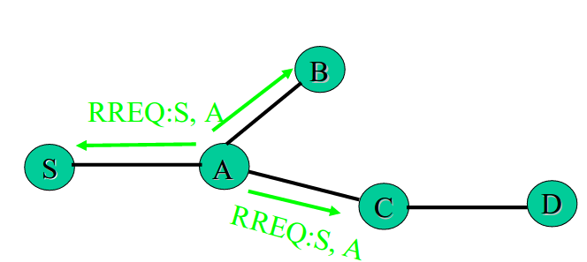

4. Node C receives RREQ, has no route to D
❒ Rebroadcasts packet after adding its address to source route
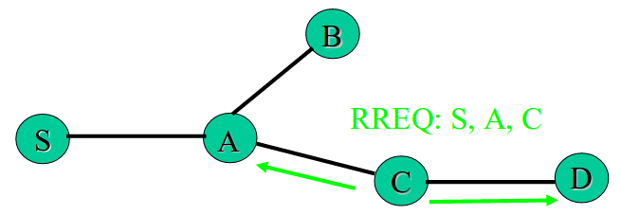

5. Node D receives RREQ, unicasts RREP to C
❒ Puts D in RREP source route

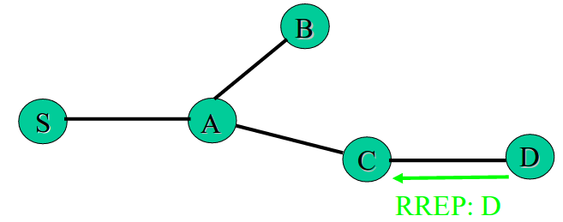

6. Node C receives RREP
❒ Adds its address to source route and unicasts to A
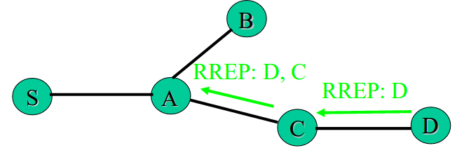

7. Node A receives RREP
❒ Adds its address to source route and unicasts to S
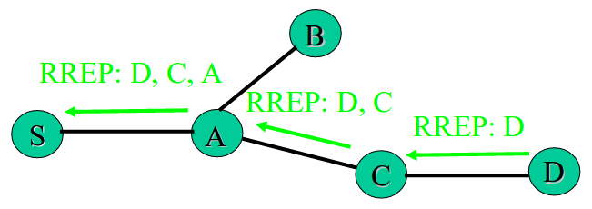

8. Node S receives RREP
❒ Uses route for data packet transmissions

- Node S on receiving RREP, caches the route included in the RREP
- When node S sends a data packet to D, the entire route is included in the packet header, hence the name source routing.
- Intermediate nodes use the source route included in a packet to determine to whom a packet should be forwarded.

AOMDV(Ad-hoc On-demand Multipath Distance Vector) [On-demand Driven & Reactive]
- AOMDV rotocol is an extension to the AODV protocol for computing multiple loop-free and link-disjoint paths.
- The routing entries for each destination contain a list of the next-hops along with the corresponding hop counts. All the next hops have the same sequence number. This helps in keeping track of a route.
- For each destination, a node maintains the advertised hop count, which is defined as the maximum hop count for all the paths, which is used for sending route advertisements of the destination.
- Each duplicate route dvertisement received by a node defines an alternate path to the destination.
- AOMDV can be used to find node-disjoint or link-disjoint routes.
- To find node-disjoint routes, each node does not immediately reject duplicate RREQs. Each RREQs arriving via a different neighbor of the source defines a node-disjoint path.
- This is because nodes cannot be broadcast duplicate RREQs, so any two RREQs arriving at an intermediate node via a different neighbor of the source could not have traversed the same node.
- In an attempt to get multiple link-disjoint routes, the destination replies to duplicate RREQs, the destination only replies to RREQs arriving via unique neighbors.
- After the first hop, the RREPs follow the reverse paths, which are node-disjoint and thus link-disjoint. The trajectories of each RREP may intersect at an intermediate node, but each takes a different reverse path to the source to ensure link-disjointness.

